# EXECUTIVE SUMMARY

We have concluded the Total Cost of Ownership (TCO) analysis comparing running your IT services on-premise versus using Microsoft 365.

The analysis has been conducted using data that we have collected from your environment and using a TCO calculator fully transparent and easy to use.

**You could save… if you move to Microsoft 365!!**

**In relative terms, this ….% of cost savings!!**

The report will detail the methodology we followed, the data that we have collected and the results you could achieve.

Our recommendation going forward is to invest in Microsoft 365 to benefit from the immediate savings, improve on the overall productivity of your organization and make it future-proof which is essentials in today’s changing environments.

# TCO ANALYSIS METHODOLOGY

The TCO analysis compares running the following IT services in your data center versus moving them to Microsoft 365:

Email Services, Users Personal Storage on File Server, Files on Share Drive Servers, Chat Application, Online Audio/Video Meetings, Anti-Virus, Single Sign-On and Device Management.

It also compares buying Microsoft licenses through Open Licensing Agreement versus subscribing to Microsoft 365.

For each of the services, we will look at:

|  |  |
| --- | --- |
| **Server** | Annual Maintenance Cost |
| Technology Refresh Investment |
| Cooling Charges (% of Total Cooling Charges) |
| Electricity Charges (% of Total Electricity Charges) |
| **Operating System - Server(s) License** | Annual Maintenance Cost |
| Technology Refresh Investment |
| **Software License** | Annual Maintenance Cost |
| Technology Refresh Investment |
| **Security Software** | Anti-Virus Licenses |
| Anti-Spam Licenses |
| **Archiving & Backup** | Operating Cost |
|  | Technology Refresh Investment |
| **Connectivity** | Leased Line |
| Connectivity to Disaster Recovery Site |

The TCO analysis also includes the costs of labor required to maintain the administer and upgrades the current systems versus deploying and migrating data to Microsoft 365.

The analysis is conducted over a period of 5 years to cater for at least one technology refresh investment.

All the data collected is then entered in a comparative Excel sheet adding all the costs together and comparing the total costs of running the systems in your data center (on-premise) versus moving to Microsoft 365.

# DATA COLLECTED

The data that we will collect is the following:

|  |  |  |
| --- | --- | --- |
| **Email Services** | Server | Annual Maintenance Cost |
| Technology Refresh Investment |
| Cooling Charges (% of Total Cooling Charges) |
| Electricity Charges (% of Total Electricity Charges) |
| Operating System - Server(s) License | Annual Maintenance Cost |
| Technology Refresh Investment |
| Software License | Annual Maintenance Cost |
| Technology Refresh Investment |
| Security Software | Anti-Virus Licenses |
| Anti-Spam Licenses |
| Archiving & Backup | Operating Cost |
| Technology Refresh Investment |
| Connectivity | Leased Line |
| Connectivity to Disaster Recovery Site |
| **Users Personal Storage on File Server** | Server | Annual Maintenance Cost |
| Technology Refresh Investment |
| Cooling Charges (% of Total Cooling Charges) |
| Electricity Charges (% of Total Electricity Charges) |
| Operating System - Server(s) License | Annual Maintenance Cost |
| Technology Refresh Investment |
| Software License | Annual Maintenance Cost |
| Technology Refresh Investment |
| Security Software | Anti-Virus Licenses |
| Archiving & Backup | Operating Cost |
| Technology Refresh Investment |
| **3rd Party Application for file sharing and transferring** | Licenses | Annual Maintenance Cost |
|  | Technology Refresh Investment |
| **Files on Share Drive Servers** | Server | Annual Maintenance Cost |
| Technology Refresh Investment |
| Cooling Charges (% of Total Cooling Charges) |
| Electricity Charges (% of Total Electricity Charges) |
| Operating System - Server(s) License | Annual Maintenance Cost |
| Technology Refresh Investment |
| Software License | Annual Maintenance Cost |
| Technology Refresh Investment |
| Security Software | Anti-Virus Licenses |
| Archiving & Backup | Operating Cost |
| Technology Refresh Investment |
| SharePoint Online Additional Storage | 1 TB + 10GB per user are included. For Additional Storage 0.2$/month for each additional 1GB |
| **Hub for Teamwork** | Chat Application | Annual Maintenance Cost |
| Technology Refresh Investment |
| Software to conduct Online Video Meetings | Annual Maintenance Cost |
| Technology Refresh Investment |
| Software to conduct Calls between Offices | Annual Maintenance Cost |
| Technology Refresh Investment |
| International calling bills (between Offices) | Annual Charges |
| **Microsoft Licenses** | Annual Licenses Costs | Bridge CAL |
| Microsoft Office Open Licenses |
| Microsoft Office Software Assurance |
| Office 365 Subscriptions |
| **Anti-Virus** | Server | Annual Maintenance Cost |
| Technology Refresh Investment |
| Cooling Charges (% of Total Cooling Charges) |
| Electricity Charges (% of Total Electricity Charges) |
| Operating System - Server(s) License | Annual Maintenance Cost |
| Technology Refresh Investment |
| Software License | Annual Maintenance Cost |
| Technology Refresh Investment |
| Archiving & Backup | Operating Cost |
| Technology Refresh Investment |
| Cooling Charges (% of Total Cooling Charges) |
| Electricity Charges (% of Total Electricity Charges) |
| **Single Sign-On** | Operating System - Server(s) License | Annual Maintenance Cost |
| Technology Refresh Investment |
| Software License | Annual Maintenance Cost |
| Technology Refresh Investment |
| Security Software | Anti-Virus Licenses |
| Archiving & Backup | Operating Cost |
| Technology Refresh Investment |
| **Device Management** | Server | Annual Maintenance Cost |
| Technology Refresh Investment |
| Cooling Charges (% of Total Cooling Charges) |
| Electricity Charges (% of Total Electricity Charges) |
| Operating System - Server(s) License | Annual Maintenance Cost |
| Technology Refresh Investment |
| Software License | Annual Maintenance Cost |
| Technology Refresh Investment |
| Security Software | Anti-Virus Licenses |
| Archiving & Backup | Operating Cost |
| Technology Refresh Investment |
| **SERVICES** | Annual Costs | Administration |
| Upgrades |
| Deployment and Migration |

# DATA COLLECTED

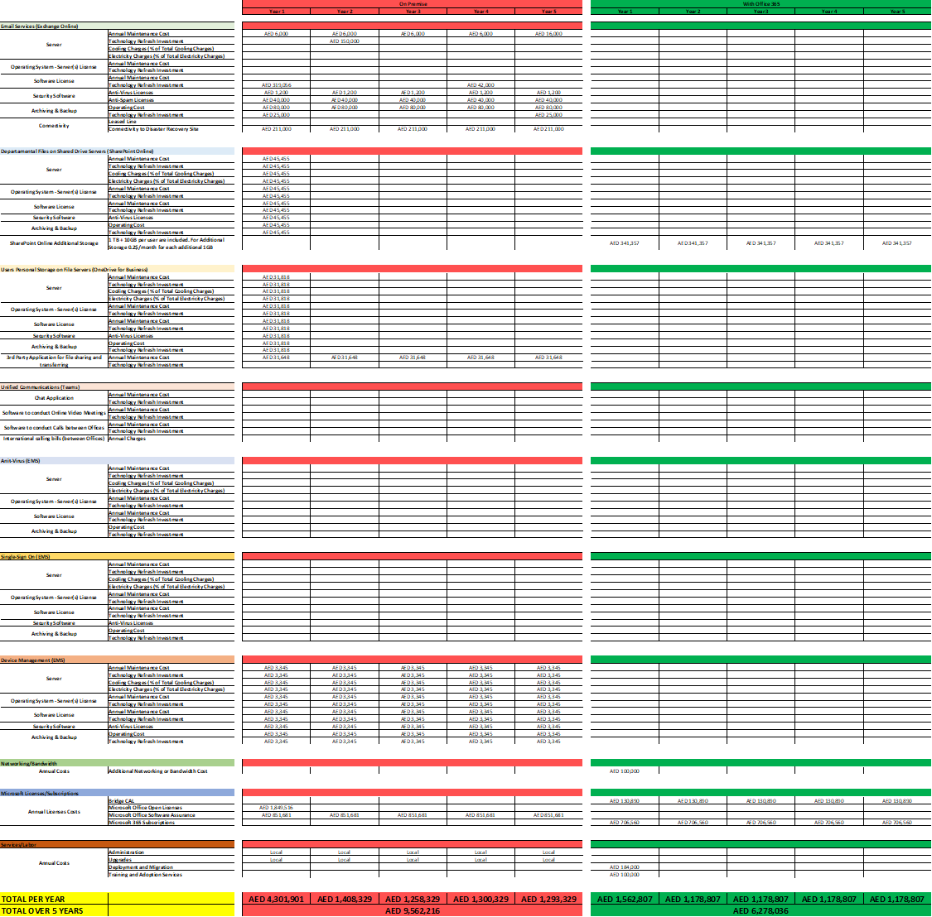

# TCO ANALYSIS SUMMARY

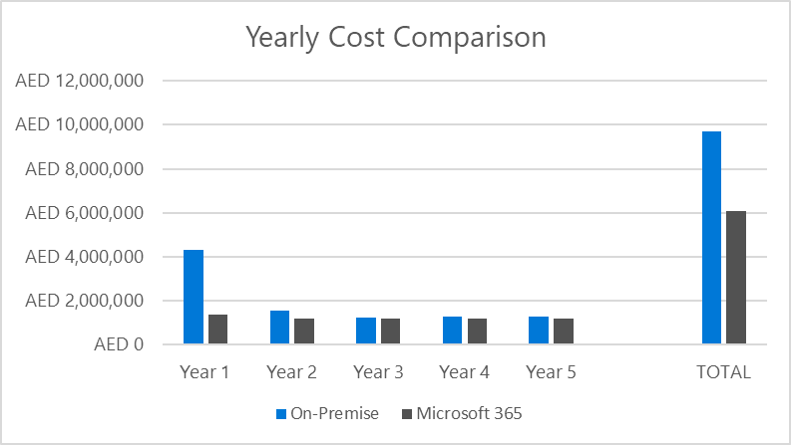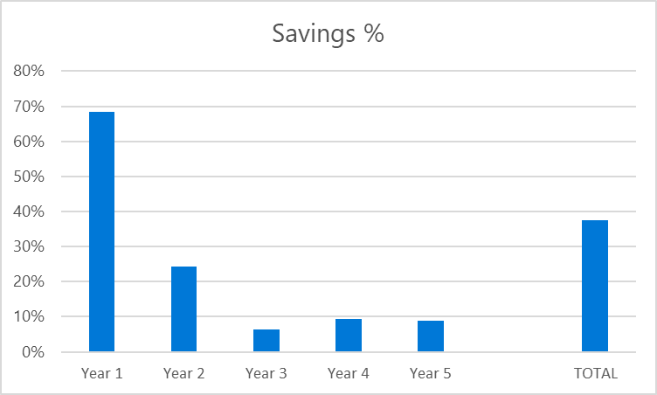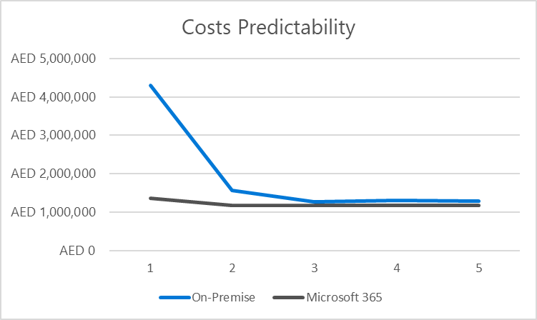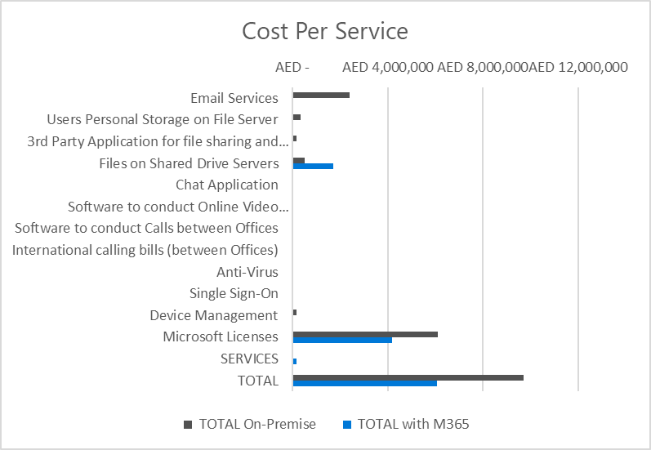

**RECOMMENDATIONS GOING FORWARD**

Given that the TCO Analysis is showing clear evidence that moving to Microsoft 365 reduces your costs of delivering the IT services mentioned above and given that Microsoft 365 brings immense improvements to the productivity of your team, our recommendation is to receive a full proposal for the same including the cost of the subscriptions as well as the professional services required for the deployment and migration of data.

The proposal must be comprehensive to include all the costs that could be incurred such as 3rd party migration tools and additional storage (if required).

Other than the deployment services, end-users adoption services are recommended too for a successful deployment and making the most of your investment in Microsoft 365.

# WHAT IS MICROSOFT 365

